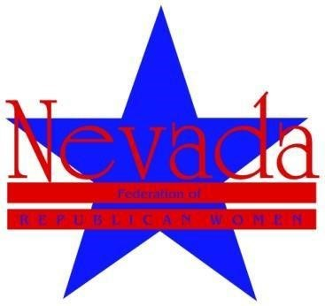
TIME TO REGISTER FOR:
NORTHERN LEADERSHIP WORKSHOP
Saturday, January 26, 2019: 9 am - 3 pm at the
Silver Legacy, Reno: 407 North Virginia
Room: Silver Baron E.
Offering ALL FULL MEMBERS and new and returning club officers training sessions, various short subject speakers: Website, Parliamentary procedures, Social Media, Nominations Chair, Citizen Advocacy and the GUMBALL IMMIGRATION video!
Report on remarks by Secretary of State Barbara Cegavske
That she gave at Southern Leadership Conference on Jan. 19.
As always a LOVELY lunch is provided for all full members courtesy of our generous Regents Program.
PLEASE REGISTER BY SATURDAY, JANUARY 19, 2019.
Simply RSVP to NvFRW Northern Director Cher Daniels
by emailing her at: cherdanielsgop@yahoo.com
In your RSVP: Please include: Your name, phone number, Club, your club position if any, and YOUR EMAIL ADDRESS.
We hope to see you there!

